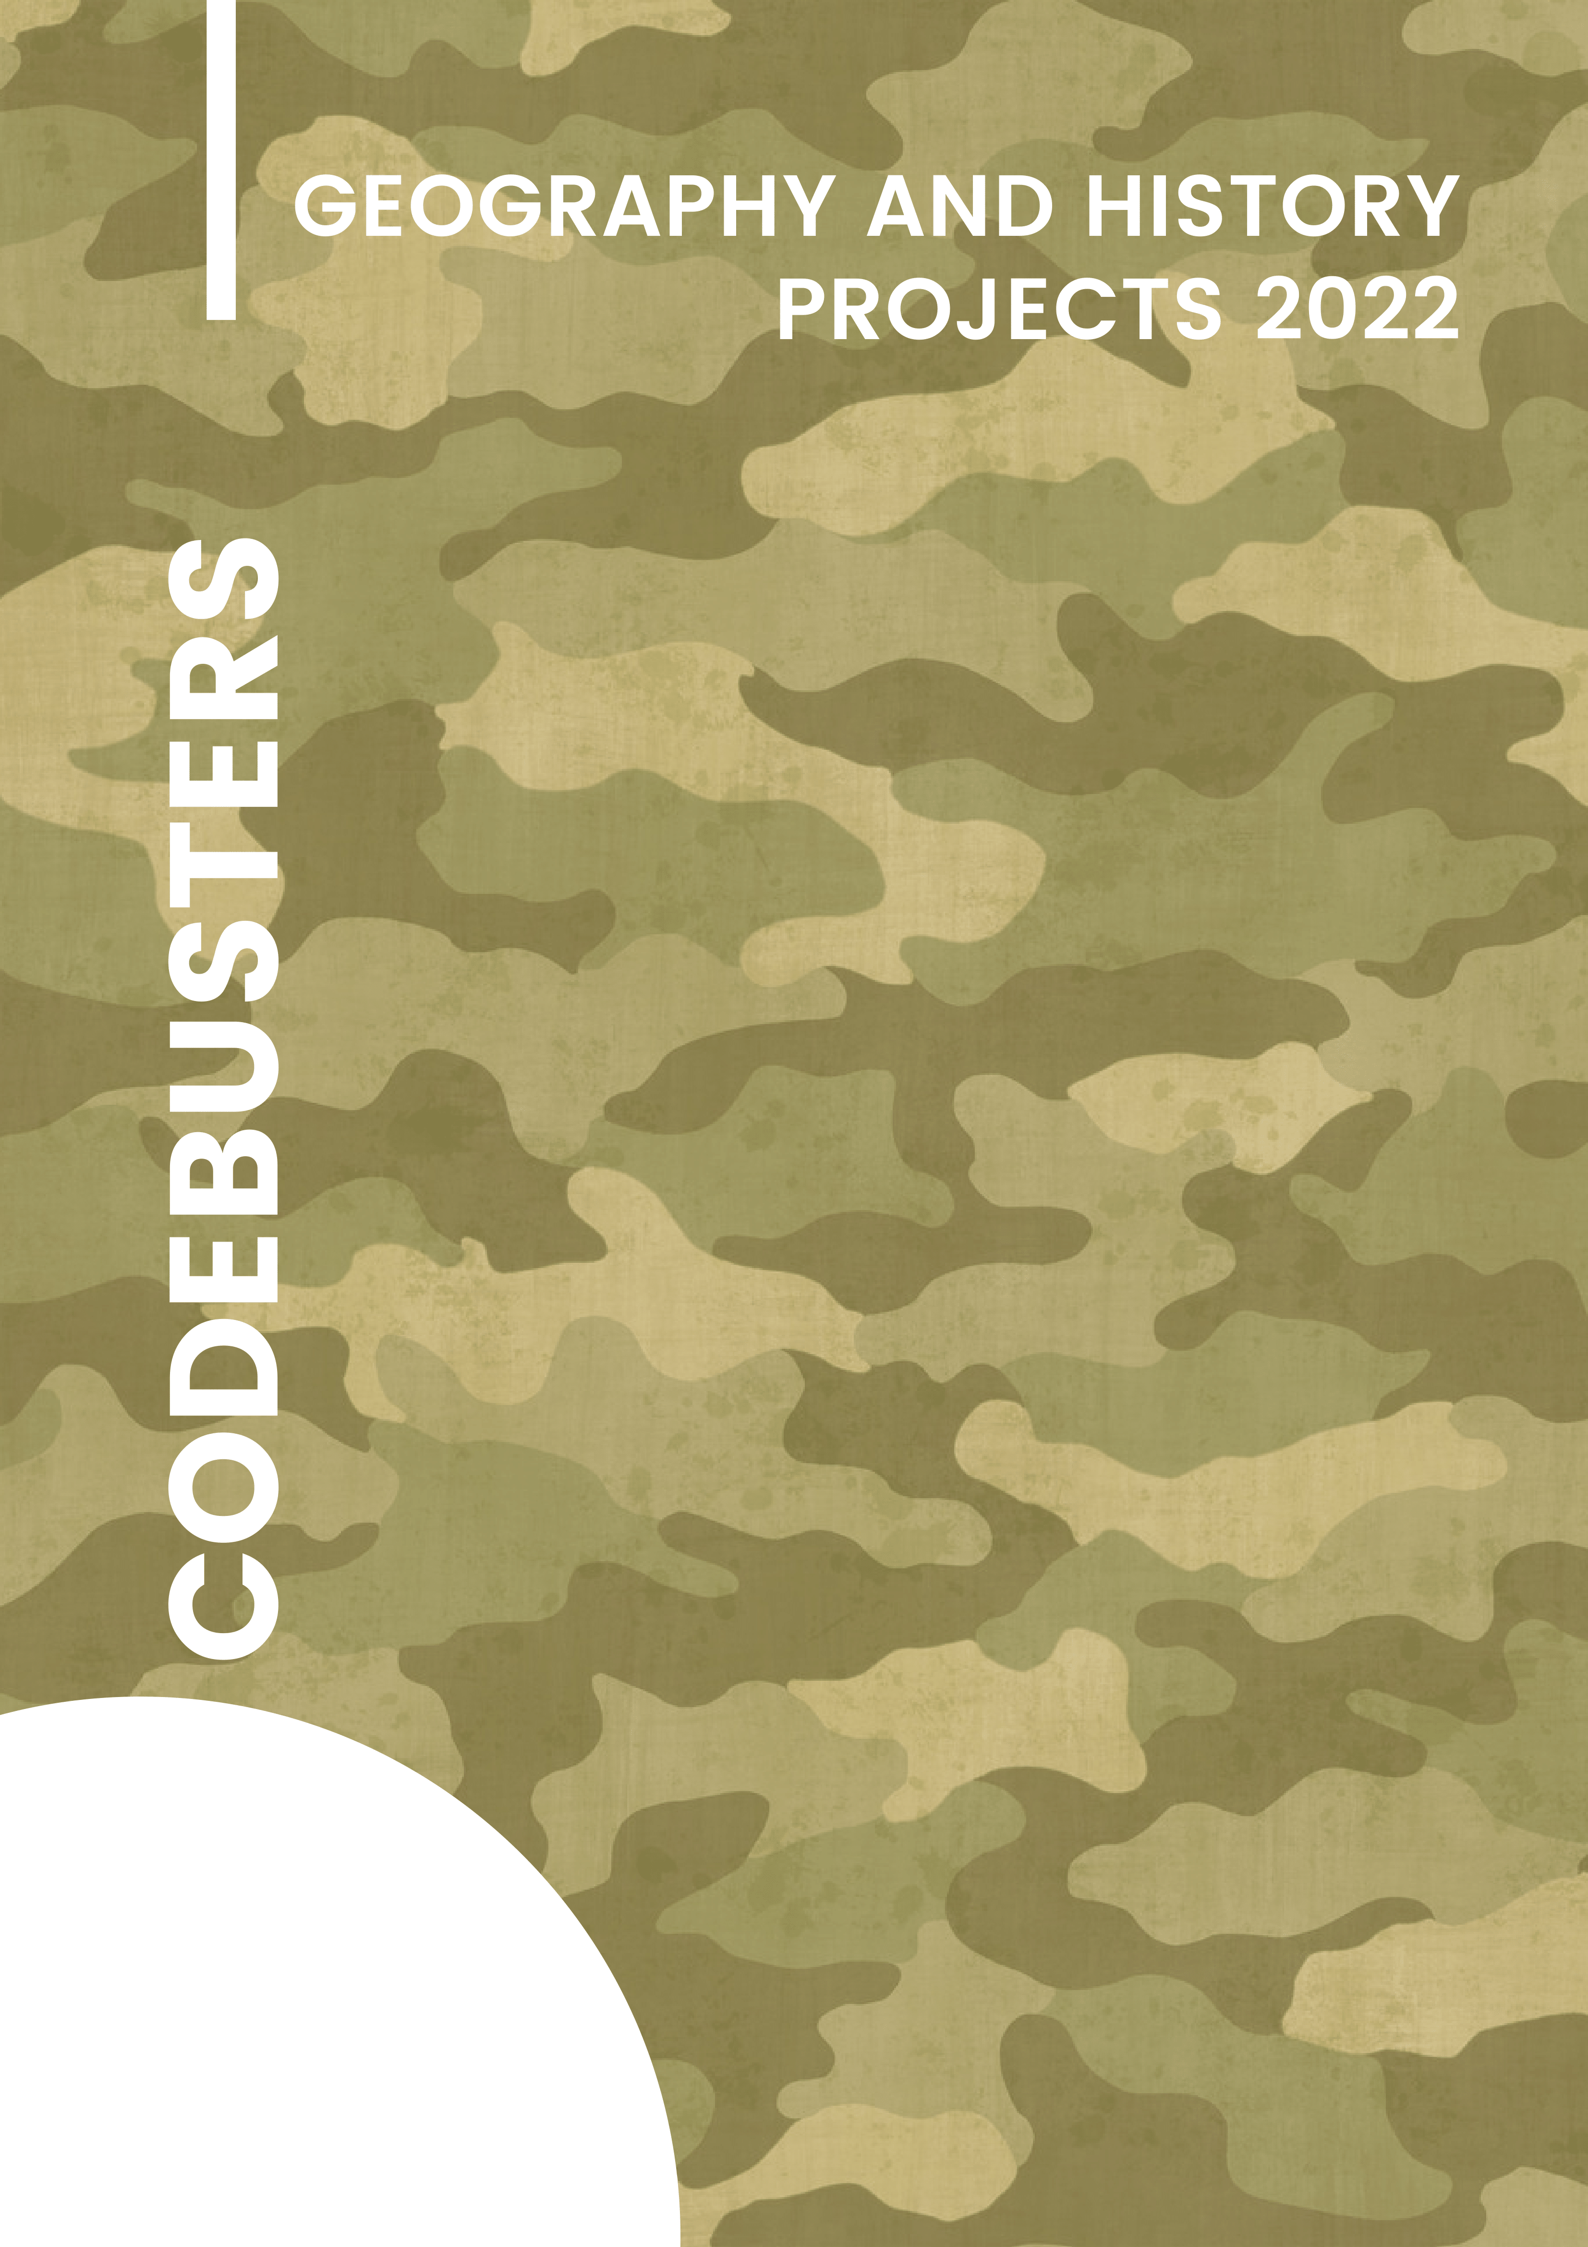

Contents

1. Project theme 2
2. Team 2
   1. Iliyana Michevska 9A – Developer Front-end 2
   2. Vanesa Kardzheva 9A – Developer Back-end 2
   3. Elena Keserzhieva 9A – Designer 2
   4. Elina Genova 9A – Scrum trainer 2
3. Resume 2
   1. Goals 2
   2. Stages of realization 2
   3. Realization 2
   4. Site 2
   5. Quiz game 2
   6. War game 2
4. Conclusion 2
   1. Solutions 2
   2. Future ideas 2
5. **Theme of the project**

The theme of our project is the historical and geographical implications of World War One. We wanted to focus on sharing useful information about this important but tragic war.

1. **Team**
   1. Iliyana Michevska 9A – Developer Front-end
   2. Vanesa Kardzheva 9A – Developer Back-end
   3. Elena Keserzhieva 9A – Designer
   4. Elina Genova 9A – Scrum trainer
2. **Resume**
   1. **Goals**

One of the main goals of our project was creating an informational site with which the user can learn new things about World War One. We did that in an interactive way - a folder which shows 3 sections, changing pictures about fronts and a real letter. The site also has custom scrollbar and custom cursor.

Besides the site, we also made a quiz game with which the user can test their knowledge. The game has a 2-player mode and assets made by us.

We also have a World War One themed shooter game. The user plays as Germany - they shoot their opponents with a weapon.

* 1. **Stages of realization**
     1. Beginning

First, we formed the team, assigned the roles and organized when our meetings would take place. Then we discussed our ideas and we were ready to start working.

* + 1. Planning

We started our work using Discord and Teams as communication platform. We discussed ideas, gave many different suggestions about how each of us sees the final product, came to consensus and started work. We allocated our tasks, each performing the tasks assigned to him on time.

* + 1. Changes

After writing the whole code, we tested it multiple times and fixed some errors.

* 1. **Realization**
     1. **Used technologies**
        1. Color scheme

#051b0a

#e9c69c

#dab784

#212120

#121313

* + - 1. Fonts

We used [google fonts](https://fonts.google.com/)' font for the main page and custom font for the letter.

* + - 1. Technologies:

1. HTML5
2. CSS3
3. JavaScript
4. GitHub
5. Discord
6. Teams
7. VS Code
8. Google Fonts
9. Draw.io
10. Canva
    * 1. **Sources:**
11. <https://www.history.com/topics/world-war-i/world-war-i-history>
12. <https://www.history.com/topics/world-war-i/world-war-i-history>
13. <https://www.standard.co.uk/hp/front/battle-of-amiens-facts-ww1-battle-a3905921.html>
14. <https://www.standard.co.uk/hp/front/battle-of-amiens-facts-ww1-battle-a3905921.html>
15. <https://www.panmacmillan.com/blogs/history/how-has-the-world-changed-first-world-war-ww1>
16. <https://www.forces.net/news/ww1-why-did-britain-join-first-world-war>
17. <https://cloudinary.com/>
18. <https://slidesgo.com/>
19. <https://fonts.google.com/>
20. <https://www.canva.com/>
    1. Graphical user interface, diagram

       Description automatically generated **Site**
    2. **Quiz game**

* 1. 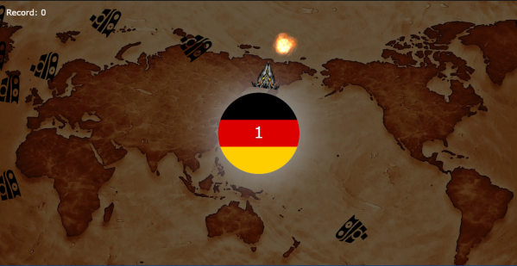**War game**

1. **Conclusion**
   1. **Solutions**

We have created an interactive informational site which teaches users facts about WW1, a Quiz game which helps to test their knowledge and a War game.

* 1. **Future ideas**

We will be working hard so that we can improve our site and games. We are looking forward to new ideas to make our product better by making it more accessible, adding more functions and hopefully cover more themes.